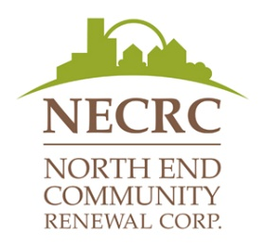

**Table & Booth Set-up Terms and Conditions**

1. Picnic in the Park will take place at St. John’s Park on Saturday August 23, 2025 from 1pm -5pm.
2. Set-up of booths and tables can begin at 12:00 pm on August 23, 2025 and are expected to be set up by 12:45 pm. Resource tables end at 5:00pm.
3. Each organization is encouraged to bring their own equipment (ie. Tables and chairs) for the set-up of their table / booth. Please advise us of any accommodations you may require.
4. Organizations are not permitted to drive into the park. Each organization must find parking outside of the park and bring all equipment into the site.
5. To ensure the event remains free for all participating in Picnic in the Park, selling of any items is not permitted at this event.
6. All booths must have a **Community Engagement Activity** at their table / booth. For example, treats, trivia, spin the wheel, raffle, etc.
7. North End Community Renewal Corporation / Picnic in the Park is not responsible for any lost, stolen or damaged items.
8. Groups / Organizations may bring additional promotional materials to be posted at their table only.

|  |  |  |
| --- | --- | --- |
| I, |  | have read and agree to the above noted terms |
| and conditions for all organizational display booths at the North End Community Renewal Corporation’s 25th Picnic in the Park event on August 23, 2025. | | |

|  |  |  |
| --- | --- | --- |
|  |  |  |
| Signature of Organization Representative |  | Date |

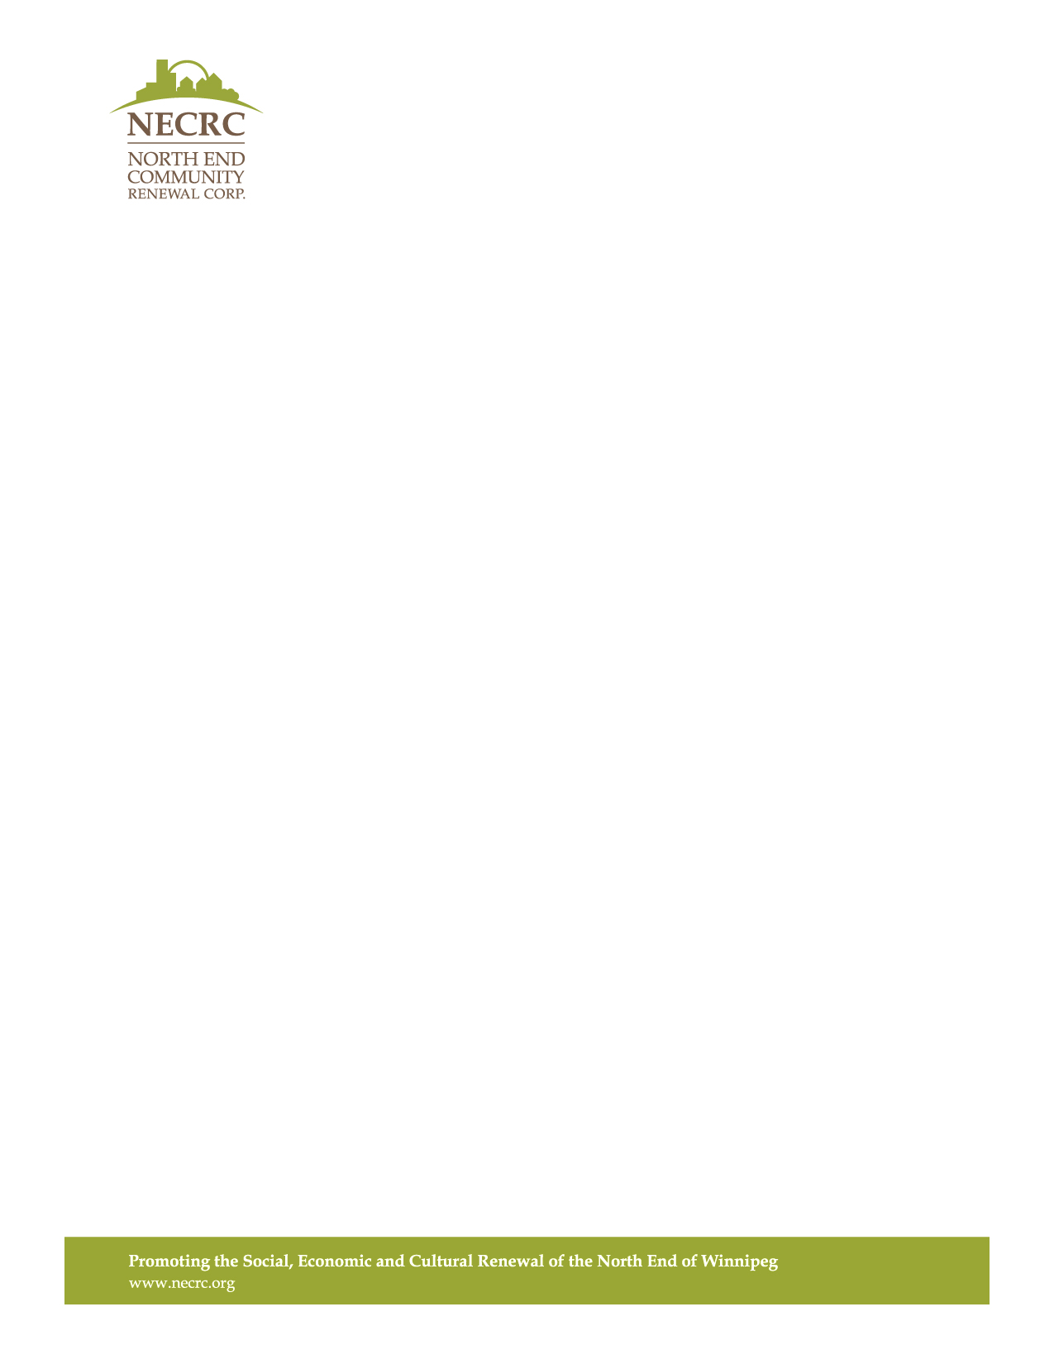**Request for a Table / Booth Set-up: Picnic in the Park 2025**

|  |  |  |  |  |  |
| --- | --- | --- | --- | --- | --- |
| Organization Name: | | |  | | |
| Address: |  | | | | |
|  | | | | | |
| Contact Name: | |  | | Title: |  |
| Phone #: |  | | | Email: |  |

We encourage all organizations to supply their own tables/chair/tents. If you cannot supply your own equipment, NECRC can provide equipment if sufficient supply is available. Please indicate how many tables and/or chairs you need:

Equipment Request: I can provide my own  Table Chair(s)  1  2

Please describe your Community Engagement Activity (see Terms & Conditions):

|  |
| --- |
|  |

Additional Notes / Comments:

|  |
| --- |
|  |

Please send your completed registration package **ON** or **BEFORE** August 1, 2025 by email to Mary at [mary@necrc.org](mailto:mary@necrc.org). You will be notified within 5-7 business days of receiving your completed registration package to confirm your attendance, provide more detailed information, and to answer any questions you may have.

**FOR OFFICE USE ONLY**

|  |  |
| --- | --- |
| Date of Application Received: | Date of Attendance Confirmed: |
|  |  |

NECRC Signature: